# **Press Release**

**47 women graduate under BCFW Cert IV Leadership & Management Course**

The Business Coalition for Women, together with its 56 member organizations joined thousands worldwide to commemorate the International Women’s Day through hosting its 6th Certificate IV Leadership & Management Course and a panel discussion.

Forty-seven (47) women graduated with a leadership and management certificate following the successful completion of the Business Coalition for Women’s Certificate IV Leadership & Management course in 2020. The combined graduation of Cohorts 11, 13 & 14 on Monday March 8th celebrated the leadership journey undertaken by these women.

“Workplaces are dominated by men and although we were in decision making positions, we were timid. But this course has enabled us to be bold and equipping us with skills to have our say in a professional and proactive manner. We are not just walking out with a certificate, we are walking out of this graduation as a champion, nation builder and we will make a difference” shared Department of Personnel Management’s GESI Officer and Cohort 13 graduand, Amelia Raka.

“The beauty about the course is it doesn’t require prerequisites. We all come with our own talents, experiences and skills to learn from each other apart from learning from the facilitators and the different competencies. Our biggest takeaway from the course is gaining self-confidence and self-belief. The course has provided a platform to network, lead, professional growth and be a positive influence in our workplaces” echoed BCFW’s program manager and Cohort 14 graduand Elizabeth Asigau.

The course aims to meet specific PNG industry needs and is designed to develop leadership and management skills of women in the workforce who have the potential to take up supervisory or managerial posts. Since its inception in 2015, nearly 200 women from 60 organisations representing a diversity of industries have graduated from the Coalition’s Certificate IV in Leadership & Management, with many of them been promoted as a direct result.

“To the women who are graduating today from Cohorts 11, 13 & 14, it is fitting that you are graduating today on International Women’s Day. The theme been Women & Leadership; Achieving an equal future in a COVID-19 world. Your voices are necessary and decision making should be shared” BCFW Executive Director Evonne Kennedy added while congratulating the 47 women.

The graduation ceremony demonstrated that PNG businesses understand the importance and benefits of having a gender diverse workforce and are committed to supporting the many talented female employees in their organizations.

‘On behalf of the BCFW team, I’d like to congratulate all the graduates from the 3 cohorts and trust the course has equipped you to be bold, step up and step out more so in the current Covid environment which will require us to be adaptive and innovative both in the workplace and at home” BCFW Chair Lesieli Taviri encouraged the graduates.

The Business Coalition for Women and facilitators of the training WINGS Education have conducted the Certificate IV leadership training for 15 cohorts. Cohorts 16, 17 and 19 will be rolled out in Port Moresby while cohort 18 will be run in Lae.

The coalition is grateful for the undying support of its member organizations towards its programs and acknowledges the efforts of each organization for recognizing the value of gender diversity and investing in the coalition’s many trainings and programmes. We say a heartfelt thank you to Pacific Palms Property and Exxon Mobil for the graduands’ gifts and Gateway Hotell for sponsoring the venue. We extend the same gratitude to local SME Pngbuzz & Cre8ive Media for livestreaming the graduation ceremony free of charge.

**About BCFW**

The Business Coalition for Women is a group of companies who are working together to drive positive change for women and businesses in Papua New Guinea and firmly establishes itself as PNG’s ‘go to’ resource for gender equality – helping businesses recruit, train, develop and promote PNG women. To learn more about the Coalition and its training programs visit: [www.pngbcfw.org](http://www.pngbcfw.org).

**Images & Captions.**

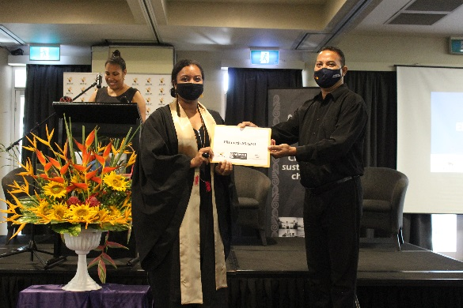

Image 1: Elizabeth Asigau receiving her certificate

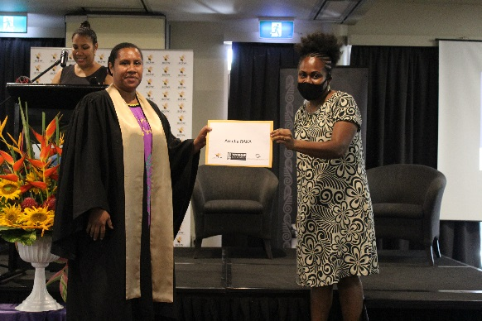

Image 2: Amelia Raka been presented her certificate

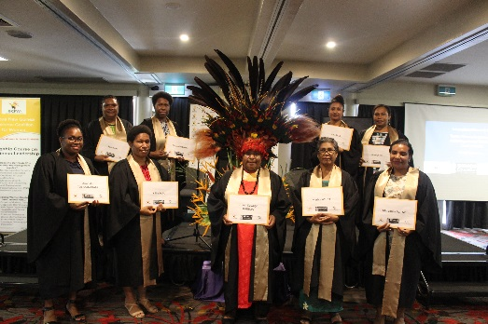

Image 3: Cohort 11 graduates pose for a group photo

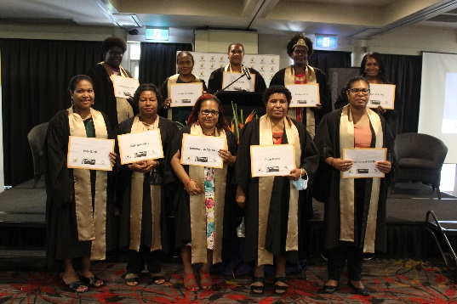

Image 4: Cohort 13 graduates display their Australian accredited certificates

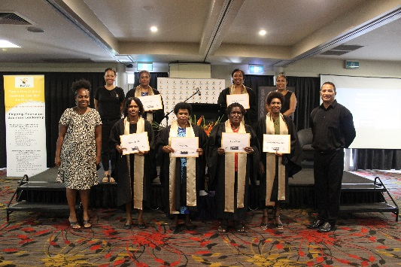

Image 5: Cohort 14 graduates flanked by WINGS Rep Gou Kere, BCFW Executive Director Evonne Kennedy, Abt Associates rep Joy Waffi & PNGAA rep Kinivanagi Karo.

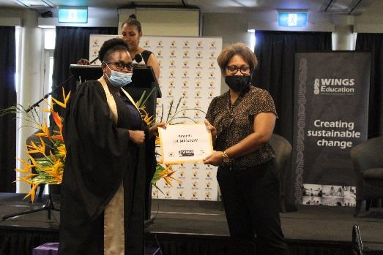

Image 6: BCFW Chair Lesieli Taviri officiating the Certificate presentation.